2nd Conference of the Postgraduate Program in Mechanical Engineering - Escola Polite´cnica Universidade de Sa˜o Paulo - Sa˜o Paulo – SP, 2024 June 05-07th

Template and Instructions
for Extended Abstracts
First Author∗, Second Author†, and Third Author‡
∗ First Author Affiliation.
† Second Author Affiliation.
‡ Third Author Affiliation.

Introduction
Use this example to format your final extended abstract. The ex- tended abstract should be written in English including Figure 1, Table 1 and references.
The extended abstract should fit in ONLY 01 PAGE in length. The extended abstracts accepted for presentation will be published and distributed to participants at the Congress.

Formats
Abstracts must be typed in two columns, like this format, each fitting inside the margins fully justified.
Position the title on the top of the first page so that it is centered. Title should be in boldface letters, followed by the authors names and their affiliations as above. The corresponding author must indicate the e-mail address.
For all headings Arabic numbers must be used, justified with the lefthand margin of the column. For subheadings, we recommend boldface.
List and number all bibliographical references at the end of the paper. When referring to them in the text, place the reference number in square brackets [1–5] as presented below.

2.1. Illustrations
The figures can be both in color and in black and white. Scanned images should have at least a 300 dpi resolution. A figure wider than a single column should not be reduced to fit; use two columns instead. Refer to figures as Figure in the text and number them consecutively as presented below. Ensure that each illustration has a caption. Centre captions preferably directly below the figure being described.

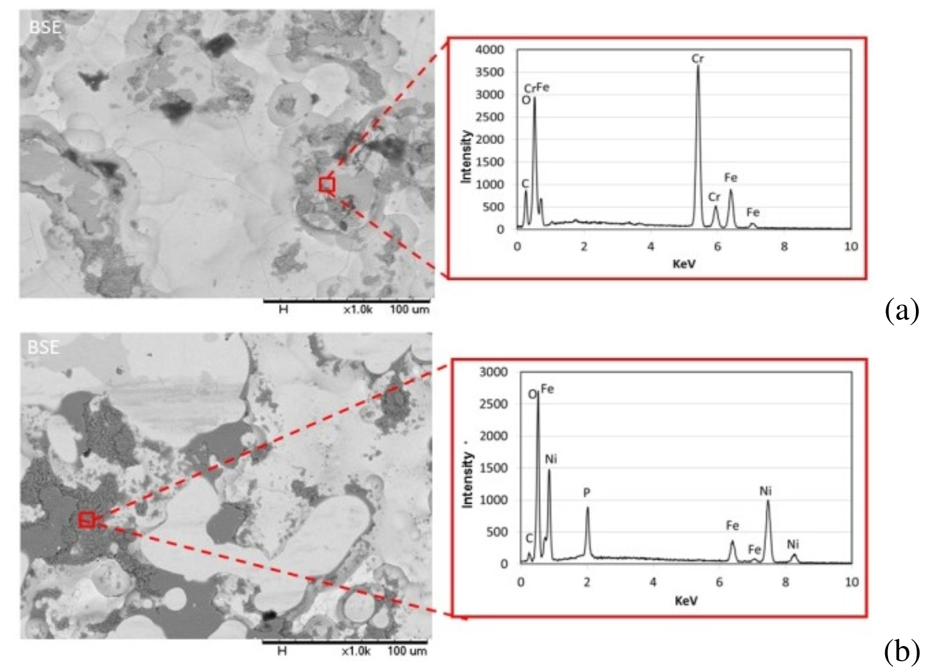
Figure 1. Figure caption

2.2. Tables
Insert tables where appropriate (as close as possible to where they are mentioned in the text). Prefer positioning them at the top or at the bottom of the column. If necessary, span them over both columns. Enumerate them consecutively using Arabic numbers and provide a caption for each table (e.g. Table 1,..). Place table captions and table legend above the table.

Table 1. Table caption
Abrasive | Mean size (µm) | Wt % slurry concentrations | Size distributions
Hematite | 0.92 | 1; 10; 40; 50 | +99% < 5 µm
Silica | 1.83 | 1; 10; 40; 50 | 80% 1-5 µm

2.3. Equations
For inserting equations, use the equation environment. Enumerate the equations using Arabic numbers in brackets on the right hand side of the equation.
$A+B=C$ (1)

$X=A×e^{xt}+21kt$ (2)

Conclusion
Send your papers only in electronic form. Papers must be uploaded before the deadline. After a paper is accepted for oral or poster presentation, one of the authors must complete a registration form and pay the appropriate fees before the paper can be published in the Proceedings. Please pay attention to the registration deadline.
References: Use Arabic numbers in square brackets to number references in such order as they appear in the text. List them in numerical order as presented under the heading ”References” at the end of this Instructions.

References
- S. L. Campbell and C. W. Gear, “The index of general nonlinear DAES,” Numer. Math., vol. 72, no. 2, pp. 173–196, 1995.
- M. K. Slifka and J. L. Whitton, “Clinical implications of dysregu- lated cytokine production,” J. Mol. Med., vol. 78, pp. 74–80, 2000.
- C. Hamburger, “Quasimonotonicity, regularity and duality for non- linear systems of partial differential equations,” Ann. Mat. Pura. Appl., vol. 169, no. 2, pp. 321–354, 1995.
- K. O. Geddes, S. R. Czapor, and G. Labahn, Algorithms for Computer Algebra. Boston: Kluwer, 1992.
- M. Broy, “Software engineering—from auxiliary to key technolo- gies,” in Software Pioneers, M. Broy and E. Denert, Eds. New York: Springer, 1992, pp. 10–13.

